Test Case: tc006_SPX_Dev5_Crear_Requisicion_Spot_Tipo_Cobro_Proyect_Urgent
Step 1 - Enter username and password and click to button Enter: Credentials Entered
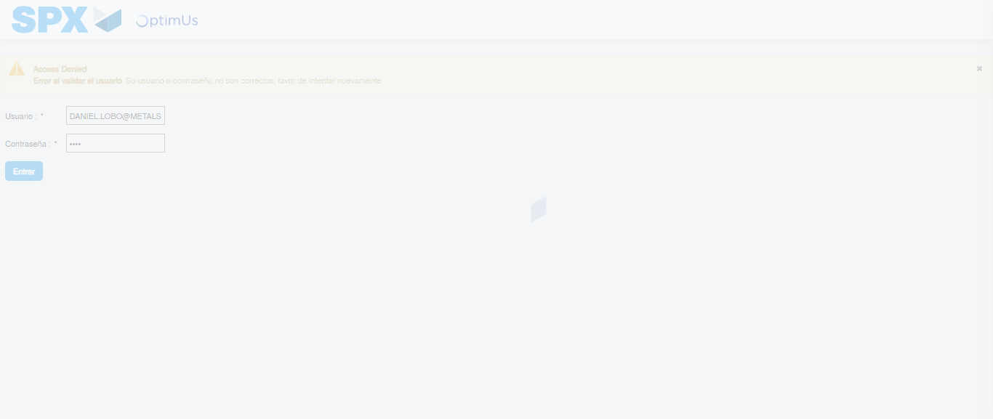Image file-name: QC_Testing-tc006_SPX_Dev5_Crear_Requisicion_Spot_Tipo_Cobro_Proyect_Urgent-1784215124540

Step 2 - Select to UEN and Access to Spot Buy Requisitions : UEN Correctly selected and Correct access
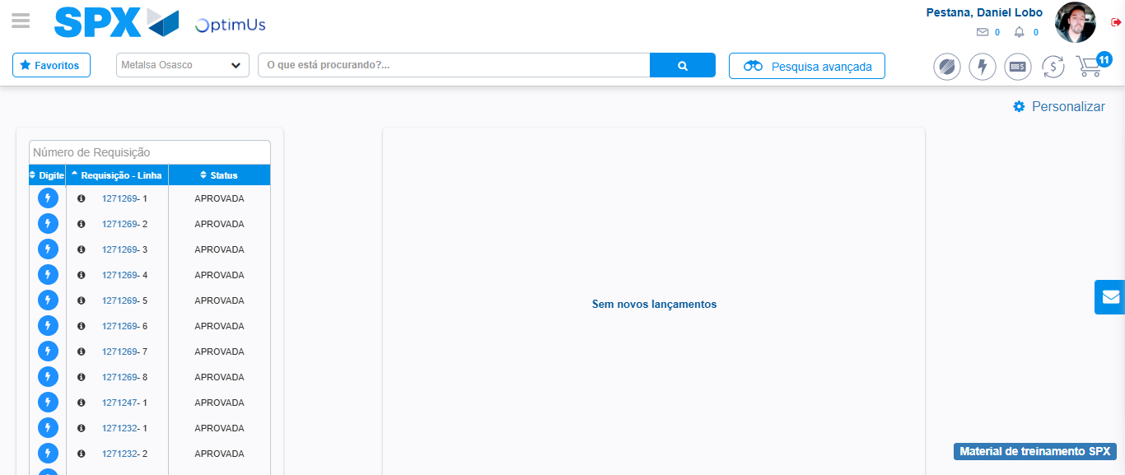Image file-name: QC_Testing-tc006_SPX_Dev5_Crear_Requisicion_Spot_Tipo_Cobro_Proyect_Urgent-1784215194149

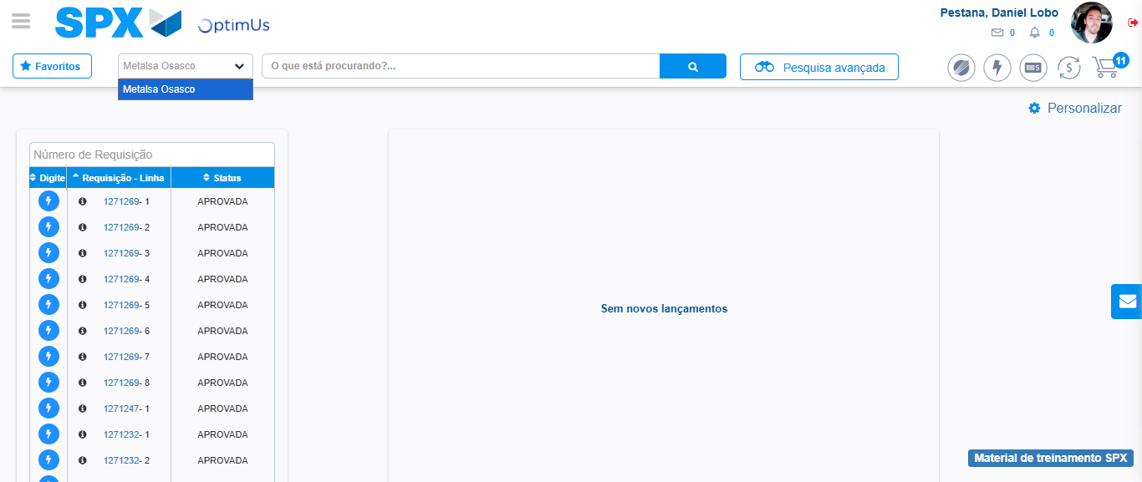Image file-name: QC_Testing-tc006_SPX_Dev5_Crear_Requisicion_Spot_Tipo_Cobro_Proyect_Urgent-1784215196867

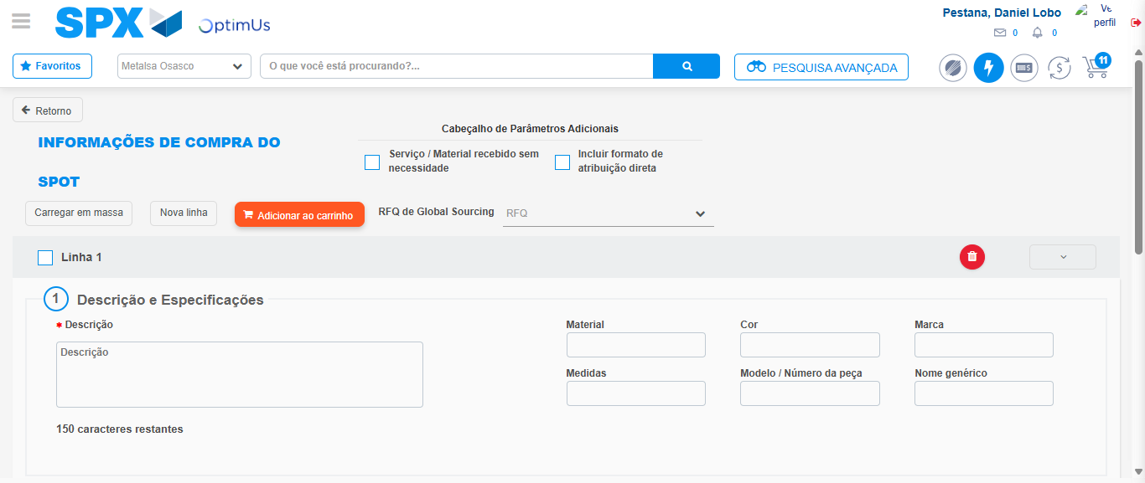Image file-name: QC_Testing-tc006_SPX_Dev5_Crear_Requisicion_Spot_Tipo_Cobro_Proyect_Urgent-1784215205460

Step 3 - Data Capture Spot Buy Requisition: Data captured correctly
Image file-name: QC_Testing-tc006_SPX_Dev5_Crear_Requisicion_Spot_Tipo_Cobro_Proyect_Urgent-1784215205737

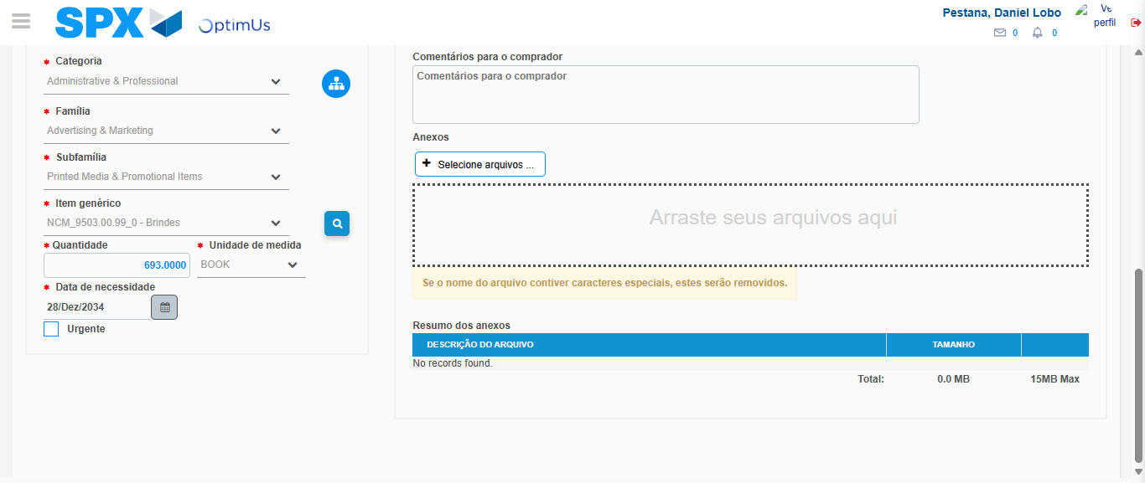Image file-name: QC_Testing-tc006_SPX_Dev5_Crear_Requisicion_Spot_Tipo_Cobro_Proyect_Urgent-1784215220110

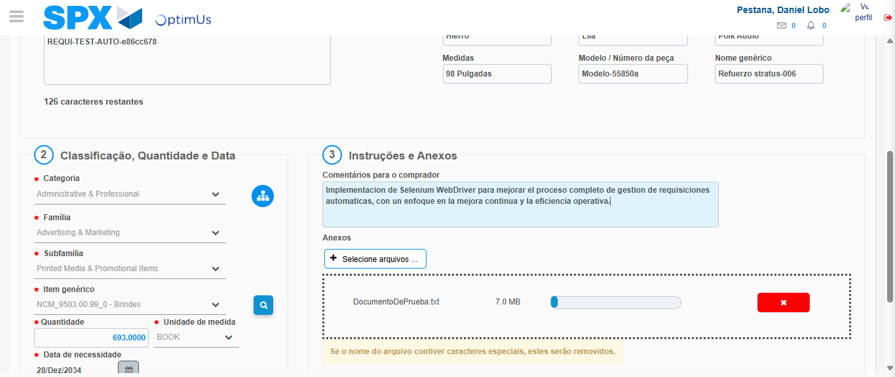Image file-name: QC_Testing-tc006_SPX_Dev5_Crear_Requisicion_Spot_Tipo_Cobro_Proyect_Urgent-1784215221116

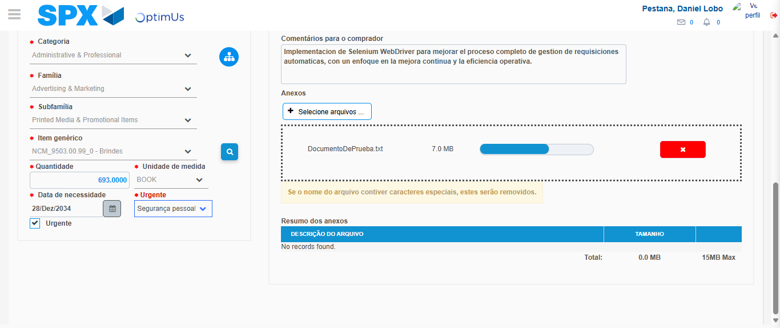Image file-name: QC_Testing-tc006_SPX_Dev5_Crear_Requisicion_Spot_Tipo_Cobro_Proyect_Urgent-1784215225051

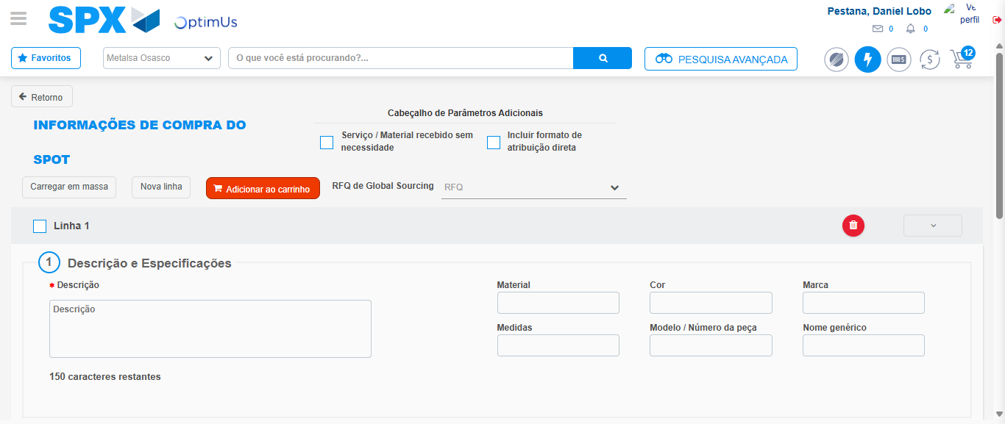Image file-name: QC_Testing-tc006_SPX_Dev5_Crear_Requisicion_Spot_Tipo_Cobro_Proyect_Urgent-1784215229254

Step 7 - Return to Main Page SPX : Return to Main Page SPX
Image file-name: QC_Testing-tc006_SPX_Dev5_Crear_Requisicion_Spot_Tipo_Cobro_Proyect_Urgent-1784215194149

Image file-name: QC_Testing-tc006_SPX_Dev5_Crear_Requisicion_Spot_Tipo_Cobro_Proyect_Urgent-1784215196867

Image file-name: QC_Testing-tc006_SPX_Dev5_Crear_Requisicion_Spot_Tipo_Cobro_Proyect_Urgent-1784215205460

Image file-name: QC_Testing-tc006_SPX_Dev5_Crear_Requisicion_Spot_Tipo_Cobro_Proyect_Urgent-1784215231520

Image file-name: QC_Testing-tc006_SPX_Dev5_Crear_Requisicion_Spot_Tipo_Cobro_Proyect_Urgent-1784215231742

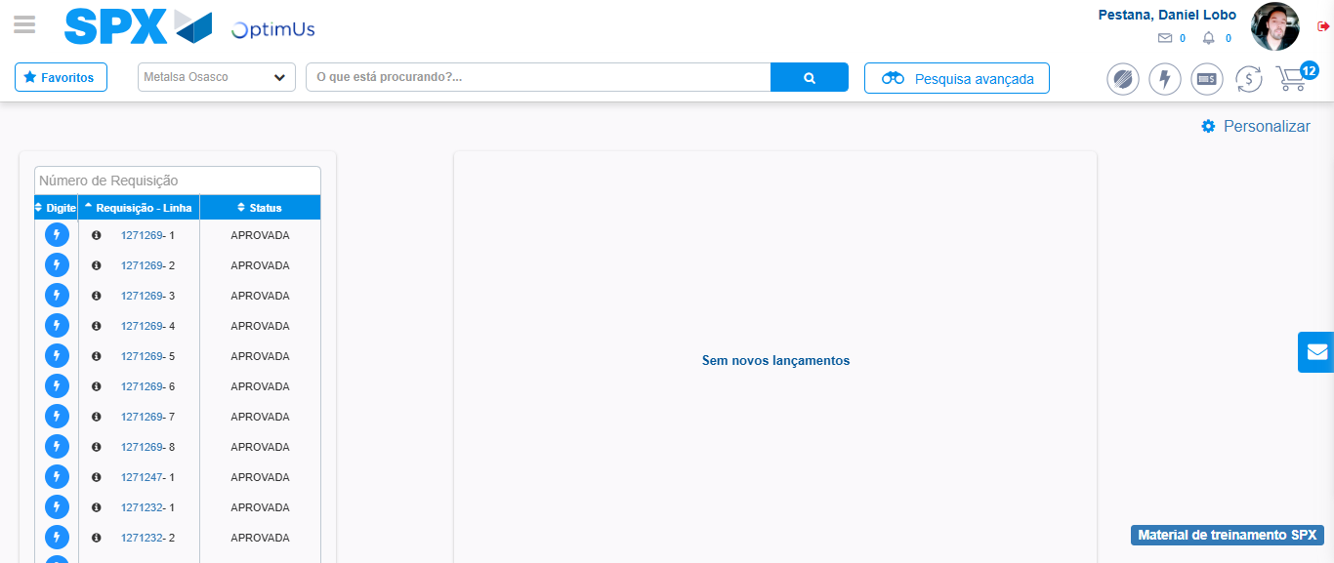Image file-name: QC_Testing-tc006_SPX_Dev5_Crear_Requisicion_Spot_Tipo_Cobro_Proyect_Urgent-1784215252924

Step 8 - Log Out : Log Out SPX
Image file-name: QC_Testing-tc006_SPX_Dev5_Crear_Requisicion_Spot_Tipo_Cobro_Proyect_Urgent-1784215253170

